Build Python Code

|  |  |
| --- | --- |
| Assignment Date | 18 November 2022 |
| Team ID | PNT2022TMID31303 |
| Project Name | AI-Powered Nutrition Analyzer For Fitness Enthusiasts |

**The first step is usually importing the libraries that will be needed in theprogram:**

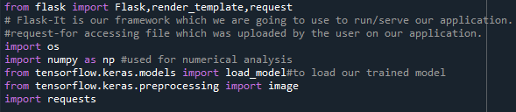Importing the flask module into the project is mandatory. An object of theFlask class is our WSGI application. Flask constructor takes the name of thecurrent module ( name ) as an argument Pickle library to load the model file.